**IBM SMARTINTERNZ**

**LITERATURE SURVEY ON THE SELECTED PROJECT & INFORMATION GATHERING**

**Survey took by:** Arun Karthick S(917719C006), Harshavarthini VS(917719C033)

**Literature Survey:**

**1.**

**Topic:** An Automated University Admission Recommender System for Secondary School Students

**Presented by:** The 6th International Conference on Information Technology and Applications (ICITA 2009)

**Authors:** Simon Fong and Robert P. Biuk-Aghai

**Inference:**

In this conference paper the authors create a recommended system which recommends the perfect university. This paper presents a hybrid model of neural network and decision tree classifier that serves as the core design for university admission recommended system.

In addition to the high prediction accuracy rate, flexibility is an advantage such that the system can predict suitable universities that match the students’ profiles and the suitable approaches through which the students should enter.

It provides decision support about recommendations to university for secondary school administrators, teachers and senior secondary students. The experiments showed that the hybrid decision tree and neural network approach improved accuracy in classification task.

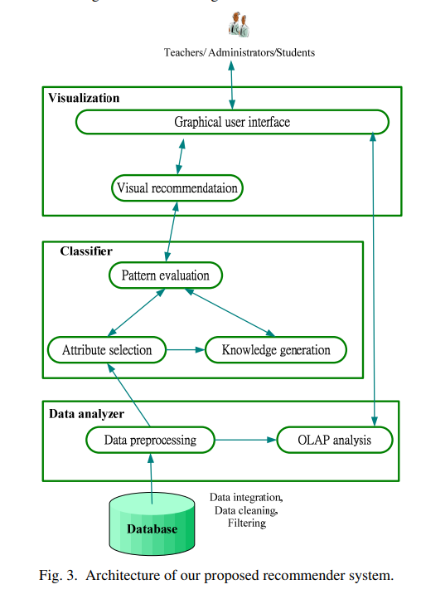

**2.**

**Topic:** Design and Implementation of a Hybrid Recommender System for Predicting College Admission

**Journal:** International Journal of Computer Information Systems and Industrial Management Applications.

**Authors:** Abdul Hamid M. Ragab, Abdul Fatah S. Mashat, Ahmed M. Khedra.

**Inference:**

This paper presents a new college admission system using hybrid recommender based on data mining techniques and knowledge discovery rules, for tackling college admissions prediction problems. This is due to the huge numbers of students required to attend university colleges every year. The proposed system consists of two cascaded hybrid recommenders working together with the help of college predictor, for achieving high performance. The first recommender assigns student’s tracks for preparatory year students. While the second recommender assigns the specialized college for students who passed the preparatory year exams successfully. The college predictor algorithm uses historical colleges GPA students admission data for predicting most probable colleges.

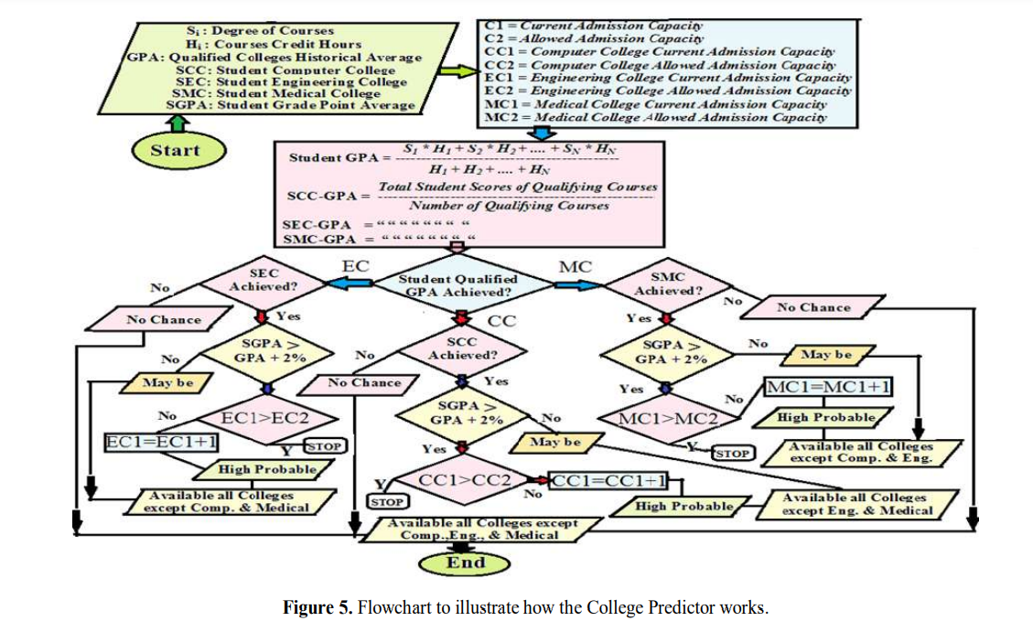

**INFORMATION GATHERING:**

* Based on these papers, we have decided to do our projects with high accuracy and using hybrid recommender.
* We try to implement good UI design.
* To increase the level of accuracy, we have decided to try random forest classifier.
* Here we use the GRE, TOFL scores along with CGPA for predicting the most probable colleges.
* This algorithm uses the previous scores and statistics as reference and predicts the most probable college for the students with high accuracy and high performance.